HANDOUTS

AE Workshop #505

Ex Nihilo – Creating a Lesson or Study When no Curriculum Exists

Quote from Dr. Cynthia Rigby’s seminal work titled, “Holding Faith: A Practical Introduction to Christian Doctrine”

Reclaiming our Creative “Good-ness”

“From the vantage point of our daily lives, then, this idea that the God who creates ex nihilo and who admittedly stands in clear distinction from the created order can and does enter wholly into creation itself helps us think more deeply about the character of all intimate relationships.”

“To uphold the creation ex nihilo, then, is to confess that we really have been met by the Other, in our creation.”

“In other words, the creation of the lecture and the presentation of it is certainly out of something. But there are those moments when the something is forgotten, where there is a transparent, immediate relationship between me and the creation that is the lecture. In those moments, creation feels like perfect participation in something that is real. It feels like relationship itself.”

Found in Chapter Five, Who Did God Create Us to Be, and What Went Wrong? Pages 159, 160, 161

Ex Nihilo –
Creating a Lesson or Study When No Curriculum Exists

Why We Are Here

- We are here to learn how to take a “germ” of an idea and create a short-term study or a few lessons starting with the idea nugget

- We are here to develop a bit more confidence in our ability to create a “curriculum” on our own

- We are here to discover and tap into parts of our creative selves, which is critical in this creative process

- We are here because sharing faith and knowledge creatively is part of how God has wired us – so let’s tap into that energy

Let’s Begin

- We begin with the “germ” or seed of an idea

- Identify the intended audience

- Examine what it is we want this idea to convey and how we can encourage the sharing of faith and knowledge creatively and effectively within the scope of the idea

- Take inventory of the tools available to us in this creative process; this includes in our planning, employing multiple intelligences, solid research and preparation, and prayerful consideration on the purpose of these lessons or presentations

- Create an outline for the study by pulling together what our inventory has shown will be helpful

Sample Topic to Practice the Creative Lesson Process

The 23rd Psalm – 4 part study (see handout)

This study idea came to me last year at the Annual Event as I listened to our keynote speaker, John Pavlovitz, talk about this Psalm in a new a resourceful way. In my mind I thought what a great 4-part lesson study series this would make for an adult or youth class.

On the handout and up on the screen you will see my initial notes that I wrote down immediately upon returning from the annual event.

We are going to work together to create this series. The main point in this series, at least in my mind, is to focus on the action verbs MAKES, LEADS, GUIDES and PREPARES. The idea is to see how God is in intimate relationship with us. God is caring for us in a firm yet tender way.

John’s talk spurred creative ideas in me as I thought about the gift of giving a group of believers a fresh new way to read this most familiar psalm.

John Pavlovitz words were meant to encourage us to think about our relationship to God through the words of the 23rd Psalm:

- The Reluctant Rester
- The Blind Traveller
- The Confused Follower
- The Nervous Guest

“The Lord is my shepherd, I shall not want. He makes me lie down in green pastures…” Vs. 1-2a MAKES

“…God leads me beside still waters; he restores my soul.” Vs 2a-3a LEADS

“God guides me in right paths for his name’s sake.” Vs2. 3b GUIDES

“You prepare a table before me in the presence of my enemies; you anoint my head with oil; my cup overflows.” Vs. 5 PREPARES

A Multiple Intelligences Theory Primer

- First published by Howard Gardner in his 1983 book “Frames of Mind”
- Simply put we all have ways in which we learn best, ways in which information most effectively reaches our brains
- Generally speaking the multiple intelligence areas most commonly referred to in learning situations are:
- Music/kinetic (experience, hands-on)
- Linguistic (talking and active listening)
- Logical/mathematical (facts and reason)

Tools for a Multiple Intelligences Approach
Stories
Art
Music
Cinema
Visual Cues
Activities
Body Movement

Lesson Contents

- Opening Prayer, devotional, music or other mind focusing activity

- Background information on the 23rd Psalm (historical, theological or interesting nuggets)

- Highlight of the purpose of the study and then focus on the verse to be explored together

- Always have a “so what” section in your lesson. A time when the group reflects on what has been explored and “what it means in their lives today.”

- Closure experience that ties everything up and sets the scene for the next session
Planning the First Lesson…

- Research the 23rd Psalm – authorship, historical context, how it has been used over the centuries, etc.

- Look at various translations of the text and compare

- Take time to read this entire psalm, not only in your preparation, but also make time to read it aloud in the class at each session (do this creatively – read solo, reader’s theater, hear it sung, sing it together using a hymnal version, etc.)

- Focus on the specific verse and lesson for the day and the action verb “MAKES” which is a very intimate thing between God and me: The Reluctant Rester - “The Lord is my shepherd, I shall not want. He makes me lie down in green pastures…” Vs. 1-2a

- Look for photos or artwork that demonstrate the act of making one to lie down i.e. a parent rocking a child to sleep or a caregiver helping an invalid lie down

Create discussion questions - here are some ideas…

- Ask what it feels like to be “made” to do something or to “make” someone else do something

- Discuss the intimacy between us and God inferred in the first two verses

- Explore human stubbornness and why sometimes it takes being made to do something to get our attention

- Talk about resting and sometimes we are made to rest when an illness knocks us for a loop and we are forced to lie down

Challenges and Pitfalls

- There is more work involved when no curriculum exists because one must do their own research and create their own handouts, visuals, audio materials, etc.

- When doing one’s own research, the leader needs to be mindful to make use of good quality, authoritative sources for the information that is gleaned for sharing in a lesson

- Technological know how is important and if that is not something the leader is comfortable using in the creation of the lesson then ask for help and get others involved in the process

- “Proof-texting” is a big pitfall when choosing something that does not have a curriculum already created. In other words beware of using biblical texts out of context to “make them fit” what ever your are trying to teach


Study Ideas From Unlikely Sources

Books…

All Creation Waits by Gayle Boss

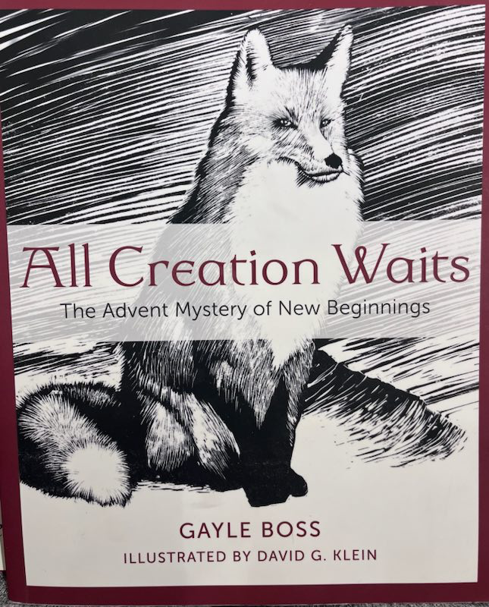
Using the book as a basis and the Advent scriptures for that particular year, I created a 4-part series that included excerpts from the book, artwork, music, dramatic readings of sections of the book, theological and historical facts about advent and videos.

The Three Questions – Based on a story by Leo Tolstoy

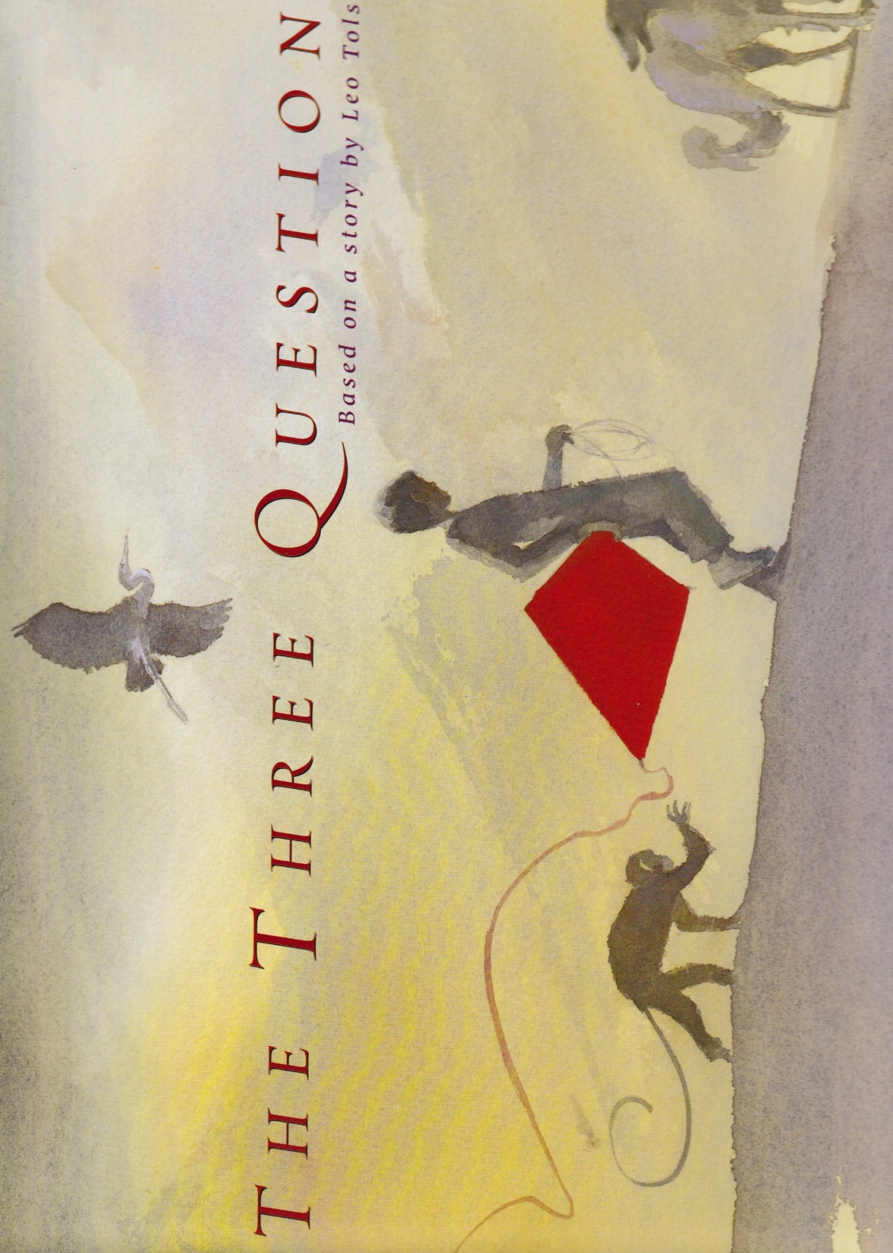
The story of a young boy, Nikolai, who seeks the counsel of the old turtle, Leo about the true meaning of life and what is most important. This is a Zen based concept but is readily transferrable to the teachings of Christ.

Movies…

The Whale Rider – Discerning the call to lead

The King’s Speech – Conquering fear

Chariots of Fire – Dedication and devotion in faith
Artwork…
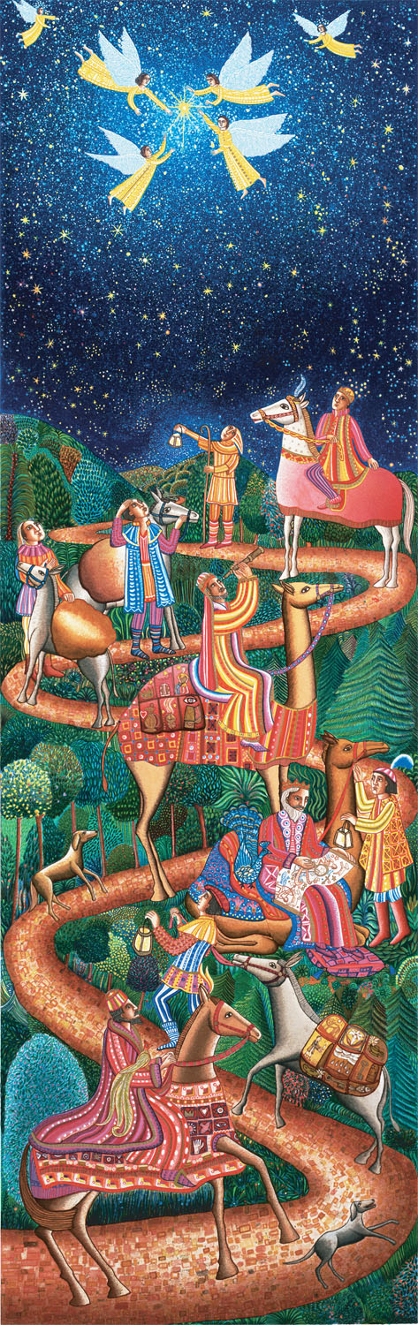
Swanson Nativity Panels

Stunning lithography panels created by John August Swanson; a series of panels depicting scenes from the nativity. Candler School of Theology at Emory University has created a video study to be used with this artwork.

The Four

This is contemporary piece by Tricia Robinson that depicts the four grandmothers of Jesus. Tamar, Rahab, Ruth and Bathsheba are outsiders in their culture but whom God deemed worthy. This can be stretched to a 4-part Advent study or condensed into a quick one Sunday look at Jesus’ ancestors (think Jesse tree).
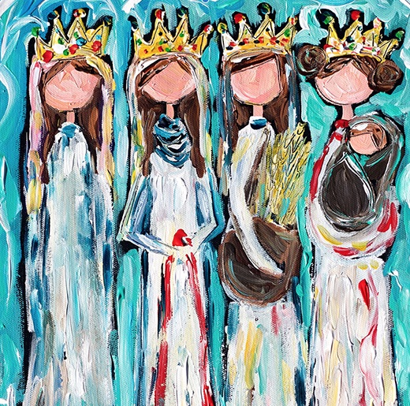

Music…

More Love (Karleigh’s Song)

Sung live on the Abraham Live album - Abraham Jam is three musicians a Christian – David LaMotte, a Muslim – Dawud Wharnsby and a Jew – Billy Jonas. This song particular song is about being overwhelmed by the world’s problems and our main task is to “put more love in the world.” https://abrahamjam.com/

Also, on the White Moon album is a song titled “Braided Prayer” and is the interweaving of the Christian prayer The Lord’s Prayer sung in Spanish, the Jewish prayer Adonai Elohim and the Muslim prayer XXXXX. This would be a great study on prayer from three major religions of the world and honoring each other’s faith. https://www.youtube.com/watch?v=wJSf5thgheI&pp=ygUaYnJhaWRlZCBwcmF5ZXIgYWJyYWhhbSBqYW0%3D

Drama…

Try your hand at writing a skit using a children’s Bible as the source. It is fairly simple to write a script with a couple of key parts plus a narrator. Throw in a few costumes if you like and you have created a new way for the class to engage with the text.

It’s okay, adults and youth actually respond well to drama or a reader’s theater.

Group Activities…

Perhaps a lesson could benefit from a weaving project to engage everyone in active participation. See the story and pictures about the Faith and Grief Memorial Arch https://www.faithandgrief.org/arch/

Idea – story of David and his coat of many colors. Post on the wall a large outline of David’s coat. At the close of the study ask each member to add a stripe of paint to the coat as they describe one characteristic of David.

Adults like art too…
RESOURCES LIST

These are resources that I regularly use in my lesson planning for Adult classes…

- Harper’s Bible Commentary

- Bible - NRSV and The Message

- Celtic Daily Prayer volumes 1 and 2 and Celtic Daily Prayer (original volume edited by Richard Foster)

- A Barclay Prayer Book

- Any prayer books from Wild Goose or the Iona Community such as An Iona Prayer Book by Peter Millar

- Glory to God Hymnal

- www.textweek.com Scripture resource website

- Wishful Thinking “A Seeker’s ABC” and Peculiar Treasures “A Biblical Who’s Who” both by Frederick Buechner

- YouTube for music, videos, and more

- Google Image search for artwork and other visual aides

- Folks this list could go on and on but you are resourceful and know how to find good resources for your creative lessons – I am convinced of it! So go forth and be creative in the name of God our Creator, Christ our Courage-giver and the Holy Spirit our Breath of Life.

